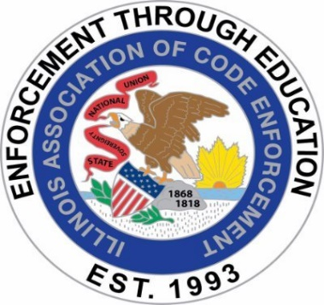

ILLINOIS ASSOCIATION OF CODE ENFORCEMENT
BUSINESS MEETING MINUTES
MEETING DATE: March 19, 2025
MEETING LOCATION: GoToMeeting / Virtual
MEETING TIME: 8:00 a.m.

Meeting called to order: 8:01 a.m.

Roll Call:

Present:

President Angel Schnur Angel.Schnur@Skokie.Org
1st Vice President Kory Hintzsche KorineHintzsche@algonquin.org
2nd Vice President Brian Smith bsmith@southholland.org
3rd Vice President Justin Howe jhowe@bataviail.gov
Treasurer Mark Blickhahn mblickhahn@vniles.com
Sergeant-At-Arms Kerry Demski Kpiercedemski@stcharlesil.gov
Secretary Tim Ostermann tosterma@bataviail.gov

Not Present: N/A

Approval of Minutes:
- Justin Howe motioned February 20, 2025, for board minutes approval with seconding Tim Ostermann motioned, all present in favor.

Changes to the agenda: None

Officer’s Reports:

President: Angel Schnur: No Report
1st Vice President: Kory Hintzsche: No Report
2nd Vice President: Brian Smith: No Report
3rd Vice President: Justin Howe: No Report
Treasurer: Mark Blickhahn: 21,527.15 total taxes being sent to accountant next week
Sergeant-At-Arms: Kerry Demski: She sent emails to Angel Schnur about crime free housing, rentals and pension info. Angel Schnur will write an email. Kerry Demski to resend to Angel Schnur
Secretary Tim Ostermann: No Report
OLD BUSINESS:

April Training:
- Angel Schnur states he slated presenter cannot commit to April due to personal reasons. Angel Schnur states that Kerry Demski has offered a contract for emergency management. They are prepared to instruct the morning topic for emergency preparations but no topic for the afternoon, they are working on. Topic TBD to get people registered. Non-Members Vs. Members rates are $100.00 and $75.00 respectively.

Update on SBOC Training Day (Justin & Tim):

- Tim Ostermann reports that training went well, Sonya Shearer was well received and kept the audience’s attention the entire day. The challenge coins were well received along with other Chatzky’s. Sonya Shearer confirmed that she received payment.

Update on Sponsorship on Website (Angel):

- Angel Schnur states she reached out to Kelvin Winters who said he is interested but needs time due to personal reasons.

Advertise Bring Your Boss’s Business Card for an Additional 50/50 Ticket:

- Angel Schnur states we are reinstating 50/50 raffle to help pay for the AACE Conference for a member (TBD) attendance fee. We want to have members bring their boss’ business card and will receive an extra 50/50 ticket. Mark Blickhan and Justin Howe will run the 50/50 raffle and sell tickets for 6 for $5.00.

AACE Passthrough Info Needed (Brian):

- Angel Schnur asked Brian Smith to run a list of IACE members who have paid for the AACE pass through info / list so they can proceed.

AACE Conference, Kory registered, and hotel reserved:

- Angel Schnur advises that Kory Hintzsche has been registered for the 2025 AACE conference, and the hotel room has been reserved.

NEW BUSINESS:

- The training topic will be TBD but posted as such.

- Nailing Competition: Justin Howe presented info on the nailing competition and is requesting an IACE sponsor Home Depot card for the winners. It was decided to provide $100.00 @$50.00 for each winner. Justin Howe will purchase the cards and submit the receipt to Angel Schnur.

- Challenge coins: Angel Schnur has some left and will bring to the April training.

- Speaker: Kerry offered another speaker for training but not ready for April and short discussion on Skokie water main break with possible inspector mutual aid IEMA, etc.

- Executive Meeting cancelled for member status.

PUBLIC COMMENTS: None

NEXT MEETING:

- April 16, 2025, Training Seminar

- May 21,2025 8am Go To Meeting

ADJOURNMENT: 8:27 a.m.

- Angel Schnur said checks for membership are still being received. Board members are covered but must pay AACe pass through.

Advertise Bring Your Boss’s Business Card for Additional 50/50 Ticket:

