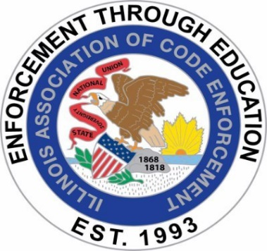

ILLINOIS ASSOCIATION OF CODE ENFORCEMENT
BUSINESS MEETING MINUTES
MEETING DATE: June 18, 2025
MEETING LOCATION: GoToMeeting / Virtual
MEETING TIME: 8:00 a.m.

Meeting called to order: 8:10 a.m.

Roll Call:

Present:

President Angel Schnur Angel.Schnur@Skokie.Org
1st Vice President Kory Hintzsche KorineHintzsche@algonquin.org
2nd Vice President Brian Smith bsmith@southholland.org
Treasurer Mark Blickhahn mblickhahn@vniles.com
Sergeant-At-Arms Kerry Demski Kpiercedemski@stcharlesil.gov
Secretary Tim Ostermann tosterma@bataviail.gov

Not Present:
3rd Vice President Justin Howe jhowe@bataviail.gov

Approval of Minutes:
- Kerry Demski motioned May 21, 2025, for board minutes approval with seconding Tim Ostermann motioned, all present in favor.

Changes to the agenda: None

Officer’s Reports:

President: Angel Schnur: No Report
1st Vice President: Kory Hintzsche: No Report
2nd Vice President: Brian Smith: No Report
3rd Vice President: Justin Howe: No Report/ Absent
Treasurer: Mark Blickhahn: No Report
Sergeant-At-Arms: Kerry Demski: No Report
Secretary Tim Ostermann: No Report
OLD BUSINESS:

Update on Sponsorship on Website (Angel):
- Angel Schnur: No Update, but, she has not been able to reconnect but will reach out to Kelvin Winters again about our sponsorship being set up on star chapter.

July training set and advertised: Angel Schnur states July training is set and advertised with Linda Pieczynski July 16,2025 and F.

Advertise for awards: We need to continue to advertise for award nominations, Angel Schnur will verify the bi laws to confirm when the deadline is to post/ advertise.

Advertise for board positions (President, @nd VP and Secretary): Tim Ostermann Secretary will run again for Secretary, Brian Smith 2nd Vide President will not run again but has a fill in for his position Abraham Abila. Brian Smith will work with him if voted in, the transition if need be and he will be at July Training. Angel Schnur President will be running again unless there is someone who wants it.

How many guest passes are sold so far (Brian Smith): 2 guest passes have been sold as of date. 67 tickets have been sold for July training.

NEW BUSINESS:

Sept 17 training (burnout & de-escalation): Brian has confirmed she doesn’t a not need a hotel but will reach out and confirm the details. Ask if she has info or power point presentation she would like to share.

December gifts (Yeti’s-Tim to get costs): Tim will get pricing for Yetis by July Training.

Kerry Demski: Kerry Demski states she and Justin Howe were doing the nailing competition at Batavia high School. Brings up lobbying and wants a include a display or story board depicting inspectors in their roles or conducting inspections. Kerry will get pricing for a story board and a drop-down screen with power point. We could use it at several venues and a worst code violation within IACE challenge with a gift card for prize. Short discussion on STAR Chapter with posting info.

PUBLIC COMMENTS: None

NEXT MEETING: July 16, 2025, Legal Aspects with Linda Pieczynski at B and F Elgin. Speaker Bio to follow.

ADJOURNMENT: Tim Ostermann motioned with Kerry Demski seconding
Adjournment -8:28 a.m.

