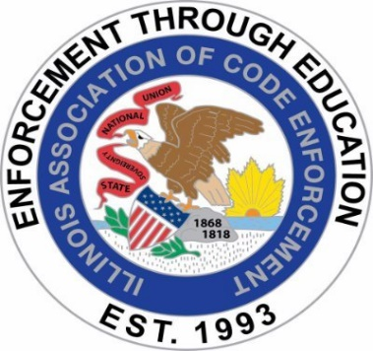

ILLINOIS ASSOCIATION OF CODE ENFORCEMENT
BUSINESS MEETING MINUTES
MEETING DATE: February 20, 2025
MEETING LOCATION: GoToMeeting / Virtual
MEETING TIME: 8:00 a.m.

Meeting called to order: 8:05 a.m.

Roll Call:

Present:

President Angel Schnur Angel.Schnur@Skokie.Org
1st Vice President Kory Hintzsche KorineHintzsche@algonquin.org
2nd Vice President Brian Smith bsmith@southholland.org
3rd Vice President Justin Howe jhowe@bataviail.gov
Treasurer Mark Blickhahn mblickhahn@vniles.com
Secretary Tim Ostermann tosterma@bataviail.gov

Not Present: Sergeant-At-Arms Kerry Demski Kpiercedemski@stcharlesil.gov

Approval of Minutes:
- Justin Howe motioned January 15, 2025, for board minutes approval with seconding Kory Hintzsche motioned, all present in favor.

Changes to the agenda: None

Officer’s Reports:

President: Angel Schnur: No Report
1st Vice President: Kory Hintzsche: Kory reports that B and F is secured for April training.
2nd Vice President: Brian Smith: No Report
3rd Vice President: Justin Howe: No Report
Treasurer: Mark Blickhahn: No Report
Sergeant-At-Arms: Kerry Demski: No Report /Absent
Secretary Tim Ostermann: Tim Ostermann asked about raffling (4) $50.00 gift cards to raffle off at the IACE Sponsored SBOC training. (Will be discussed in new business.)
OLD BUSINESS:

April Training:
- Angel Schnur states the scheduled trainer is not responding to us committing to present, Angel Schnur reached out to her plumbing inspector to possibly come and train. Justin Howe will ask Batavia’s Deputy Fire Chief if he is interested.

SBOC Sponsorship Update (March 14)-Sonya submitted forms, except payment:

- Sonya has completed forms and submitted them and set for March 14th. We will pay her invoice once it is received. Tim Ostermann and Jusitn Howe will be representing IACE

Membership update:

- Angel Schnur said checks for membership are still being received. Board members are covered but must pay AACe pass through.

Advertise Bring Your Boss’s Business Card for Additional 50/50 Ticket:

- Angel Schnur said bring your boss’s business card for an extra 50/50 raffle ticket. Will put towards the AACe annual AACE conference.

NEW BUSINESS:

Sponsorship set up on our website:

- Angel Schnur said she wants to solicit a retired member to create sponsorship set up.
The person who handles the AACe web site is doing consulting. All are in favor of seeking information and moving forward. She will get the fee breakdown. Angel will report back.

AACE Passthrough, need to submit by March 1:

- Angel Schnur said we must submit members names who have paid for the pass through and should have the list by March 1, 2025. Brian will check the membership list to verify who has paid.

AACE Conference, board member attending:

- Angel Schnur said IACE has sent two members to the AACE conference.
The past three years Kory Hintzsche has not been able to go and was offered the seat.
Tim Ostermann made a motion to give Kory Hintzsche the opportunity to attend the 2025 AACE Conference with Justin Howe Seconding, all present voted in favor. Kory will attend.

SBOC Raffle Gifts (Added) :

- Tim Ostermann is requesting IACE provide $200 in gift cards (4) $50.00 cards as done in the past to raffle off to SBOC membership at the March 14th IACE sponsored training. Justin Howe made Motion to approve with Kory Hintzsche seconding with all present voting in favor.

PUBLIC COMMENTS: None

NEXT MEETING: March 19, 2025; Go to Meeting

ADJOURNMENT: E.O.M. 8:23 Hrs

